Instructions for the Preparation of a Camera-Ready Manuscript in MS Word

Book Production MANAGER ^{a,1}, Second AUTHOR ^{b} and Third AUTHOR ^{b}
ª Book Production Department, IOS Press, The Netherlands
^{b} Short Affiliation of Second Author and Third Author

Abstract. These instructions are designed for the Preparation of a Camera-Ready Manuscript in MS Word 2 and should be read carefully. If you have any questions regarding the instructions, please contact the Book Production Manager, by e-mail: bookproduction@iospress.nl or fax: +31-20-6870039.
Keywords. Camera-ready manuscript, IOS Press, MS Word, book, layout, style
Introduction
This document provides instructions for style and layout, information on installing the Word template available from our website (optional) and how to submit the final version. Although it was written for individual authors contributing to IOS Press books, it can also be used by the author/editor preparing a monograph or an edited volume. Note that using the Word template is optional, and intended for experienced users. Unfortunately IOS Press can not give technical support on it. However, we strongly recommend that you download and install the template, and use it where you can. These Instructions also contain the necessary information for manual editing. Authors should realize that the manuscript submitted by the volume editor to IOS Press will be almost identical to the final, printed version that appears in the book, except for the pagination and the insertion of running headlines. Proofreading as regards technical content and English usage is the responsibility of the author.
1. Microsoft Word Template
The MS Word template IOSPressBookArticle.dot can be downloaded from the Author's Corner at www.iospress.nl. Place the file in any of the directories where MS Word looks for templates. These directories are defined within MS Word under
Tools/Options/File Locations.

¹ Corresponding Author: Book Production Manager, IOS Press, Nieuwe Hemweg 6B, 1013 BG Amsterdam, The Netherlands; E-mail: bookproduction@iospress.nl.
² For authors using LaTeX separate Instructions as well as a template file for LaTeX2e are available from the Author's Corner on www.iospress.nl. LaTeX styles required for the LaTeX template are also available.
1.1. Creating a New Document with the Word Template
In order to create a new document, do the following:

- Within MS Word, choose File/New.
- Define the type area as indicated in Section 2.1.
- Select the template IOSPressBookArticle.dot from the list of templates. Note that the dot extension may not be visible; this depends on the user’s preferences for displaying file extensions.
- Use the styles defined in the template as much as possible to format your text (see Table 1).

Table 1. The styles defined in IOSPressBookArticle.

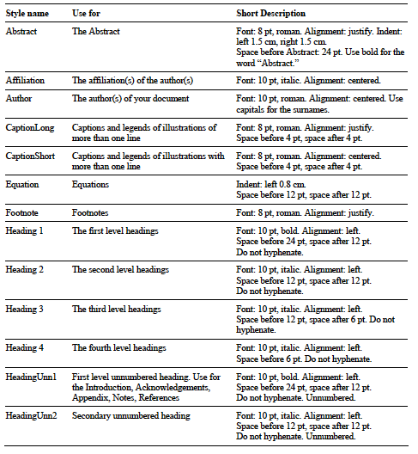

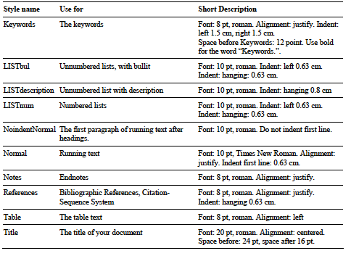

1.1.1. Notes on Table 1
A note on spacing: in Table 1 certain elements are defined with ‘paragraph spacing’, i.e. extra space before and after the paragraph (marked by ¶). This must not be confused with line spacing, which should be single throughout the document).
A note on lists: If you do not use the template styles for lists but edit the text manually, please use one of the automatic listing options in MS Word.
1.2. Re-Formatting an Existing Document with the Template
In order to apply the IOSPressBookArticle template to an existing MS Word document, do the following:

- Open the document in MS Word.
- Define the type area as indicated in Section 2.1.
- Choose Tools/Templates and Add-ins and attach the IOSPressBookArticle template to the document. Ensure that the box labelled Automatically Update Document Styles is set, as in Figure 1.
- Click OK.
- Choose Edit/SelectAll and apply the Normal style to all selected text (i.e., to the whole document).
- Save the document at this stage.
- Now work your way down through the document, applying styles to the text.

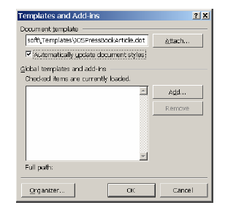

Figure 1. Setting for document template
2. Typographical Style and Layout
2.1. Type Area
Always select A4 as the paper size in the document settings. The type area is 12.4 cm wide and 20 cm long. This area must be used to the maximum, and at the same time must not be exceeded. The following margin settings for A4 size paper will produce the correct result: top 5.5 cm; bottom: 4.2 cm; left and right: 4.3 cm.
2.2. Font
The recommended type font for running text (body text) is 10 point Times New Roman. For literal text, please use one of the sans-serif fonts, or Courier.
Use roman as default style, and keep bold and italics for section headings, subsection-headings, author’s affiliations, and special emphasis. Font sizes and styles are indicated in Table 1. In order to get the correct font size and spacing, use the template styles as much as possible to format your text.
2.3. Title Page
Apply the styles defined in Table 1 for the title, author’s name, affiliation(s) and abstract. Please ensure there is a 24 pt blank line before the title! Use capitals for the author’s surname. We recommend you use superscripted alphabetic characters to identify the connections between multiple authors and their affiliations.
Use bold for the words “Abstract.” and “Keywords.” The first sentence of the Abstract should follow the word “Abstract.” on the same line.
2.4. General Layout
Use single line spacing throughout the document.
Keep the abstract, running text and long captions justified; the table text, section headings and references aligned left and center only the chapter title, author’s name and affiliation.
Indent the first line of each paragraph by 0.63 cm, except for the first paragraph after a heading.
2.5. (Sub-)Section Headings
Apply the styles defined in Table 1 to the headings.
Use initial capitals in the headings, except for articles (a, an, the), coordinate conjunctions (and, or, nor), and prepositions, unless they appear at the beginning of the heading.
2.6. Footnotes and Endnotes
Please keep footnotes to a minimum. If they take up more space than roughly 10% of the type area, list them as endnotes, before the References. Footnotes and endnotes should both be numbered in arabic numerals and, in the case of endnotes, preceded by the heading “Endnotes”.
2.7. References
References to the literature should be mentioned in the main text by arabic numerals in square brackets. Use the Citation-Sequence System, which means they are “listed and numbered in the sequence in which they are 1st cited. (...) Subsequent citations of the same document use the same numbers as that of its initial citation”[1].
To produce the reference list at the end of the article, type the reference number in square brackets, insert a tab and type the text. (Use a hard return at the end of each reference only. When the references are complete, select them all, and apply the style References from the template. For manual editing choose Format/Paragraph, and from the Indentation Special menu select "Hanging": 0.63 cm. Click OK.
As regards the content, form and punctuation of the References, if the volume editor has not expressed a preference in this matter, authors should select the format most appropriate to their article, and use it consistently.
3. Illustrations
3.1. General Remarks on Illustrations
The text should include references to all illustrations.
Refer to illustrations in the text as Table 1, Table 2, Figure 1, Figure 2, etc., not with the section or chapter number included, e.g. Table 3.2, Figure 4.3, etc. Do not use the words “below” or “above” referring to the tables, figures, etc.
Do not collect illustrations at the back of your article, but incorporate them in the text. Position tables and figures at the top or bottom of a page, with at least 2 lines extra space between tables or figures and the running text.
Illustrations should be centered on the page, except for small figures that can fit side by side inside the type area. Tables and figures should not have text wrapped alongside.
Place figure captions below the figure, table captions above the table. Use bold for table/figure labels and numbers, e.g.: Table 1., Figure 2., and roman for the text of the caption. Keep table and figure captions justified. Center short figure captions only.
The minimum font size for characters in tables is 8 points, and for lettering in other illustrations, 6 points.
On maps and other figures where a scale is needed, use bar scales rather than numerical ones of the type 1:10,000.
3.2. Quality of Illustrations
Use only Type I fonts for the lettering in illustrations.
Do not use illustrations taken from the Internet. The resolution of images intended for viewing on a screen is not sufficient for the printed version of the book.
If you are incorporating screen captures, keep in mind that the text may not be legible after reproduction (using a screen capture tool, instead of the Print Screen option of PC’s, might help to improve the quality).
3.3. Color Illustrations
Please note, that illustrations will only be printed in color if the volume editor agrees to pay the production costs for color printing. However, you should not use color in illustrations that must be printed in black and white, because this will greatly reduce the print quality. (Note that in software the default often is color, so you may have to change the settings for these illustrations.)
4. Equations
Position equations flush left with the margin, preceded as well as followed by one blank line, or use the style defined in IOSPressBookArticle.
Number equations consecutively, not section-wise. Place the numbers in parentheses at the right-hand margin, level with the last line of the equation. Refer to equations in the text as Eq. (1), Eqs. (3) and (5).
5. Fine Tuning
5.1. Type Area
Check once more that all the text and illustrations are inside the type area and that the type area is used to the maximum. You may of course end a page with one or more blank lines to avoid ‘widow’ headings, or at the end of a chapter.
5.2. Capitalization
Use initial capitals in the title and headings, except for articles (a, an, the), coordinate conjunctions (and, or, nor), and prepositions, unless they appear at the beginning of the title or heading.
5.3. Page Numbers and Running Headlines
You do not need to include page numbers or running headlines. These elements will be added by the publisher.
6. Submitting the Manuscript
Submit the following to the volume editor:
- 1. MS Word document;
- 2. Identical high resolution PDF file with all fonts embedded. Use Adobe Acrobat Distiller and choose the job option Press-Optimized.)

Please make sure you do not submit more than one version of any item.
References

[1] Scientific Style and Format: The CBE manual for authors, editors and publishers. Style Manual Committee, Council of Biology Editors. Sixth ed. Cambridge University Press, 1994.
[2] L.U. Ante, Cem surgere: Surgite postquam sederitis, qui manducatis panem doloris, Omnes 13 (1916), 114–119.
[4] T.X. Confortavit, Seras, Portarum, New York, 1995.
[5] P.A. Deus, Ater hoc et filius et mater praestet nobis, Paterhoc 66 (1993), 856–890.

